**UNIVERSITY OF VAASA**

**FACULTY OF TECHNOLOGY AND INNOVATIONS**

**DEPARTMENT OF COMMUNICATION AND SYSTEMS ENGINEERING**

**Kannan Selvan /y104838**

**Raja Vardhan Reddy Marthala/z109552**

**INDOOR POSITIONING**

**MOBILE APPLICATION DEVELOPMENT**

**VAASA 2019**

1. **Introduction**

The main aim of the project is to develop an android app for indoor positioning and routing. Motivation behind this is, Satellite are very far from the ground and signals from them are not strong enough to provide navigation indoors (inside the buildings) because of thick concrete. This solution utilizes Wi-Fi RSSI (Received Signal Strength) for positioning and routing. Android app is built with android studio.

1. **Firebase Authentication**

The identity of the user data in the application increases the overall experience to the users. The application saves the user data in the cloud and provides a wide range of personalized experiences to all the devices users connected. Firebase authentication provides backend services, effortless software development kits and libraries inbuilt to authenticate users in the application. The firebase authentication allows users to authenticate using various choices. Some of the available options to authenticate users are to use passwords, phone numbers and other identity through applications like Facebook, Google, Twitter et cetera.

Firebase Console:

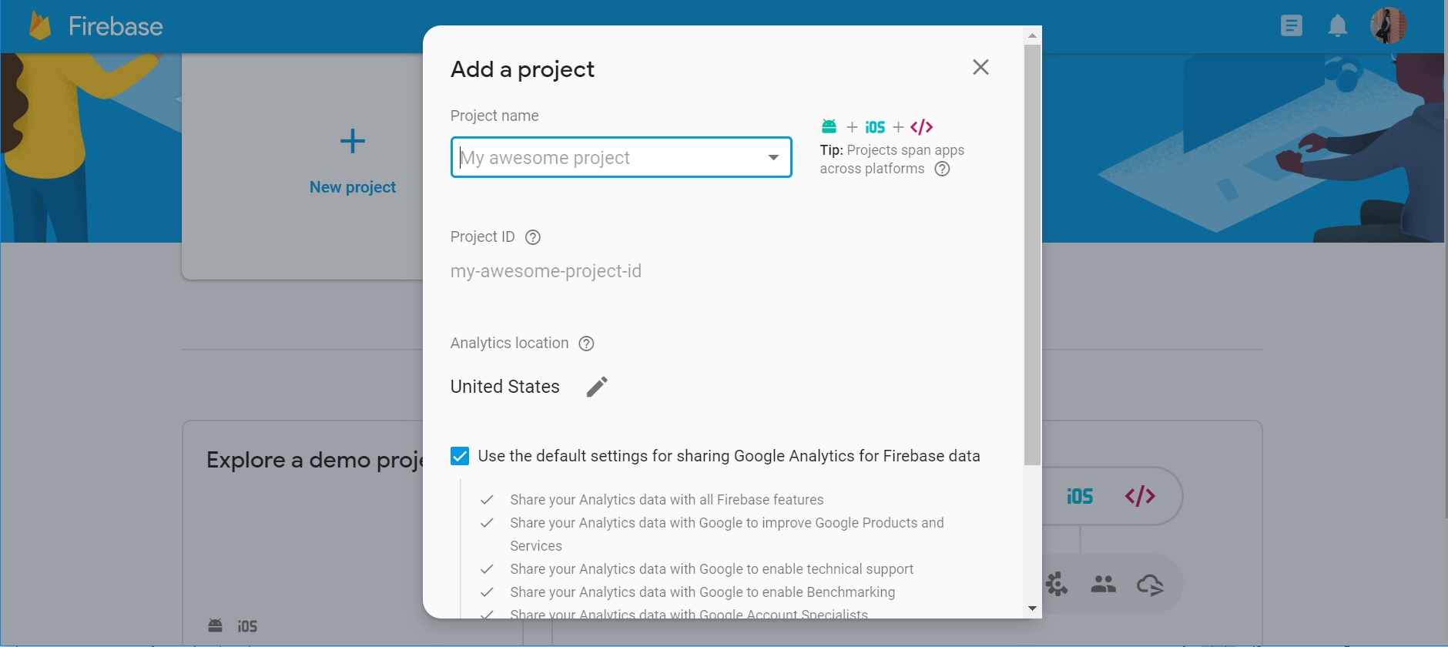

In the firebase console, we will create a new project based on the purpose of project. A single project can be used for creating several application either in an android device or an ios device. Authentication of users in several application can be provided with the same project in firebase. After creating the project, the firebase is added to the application by registering a new application as follows.

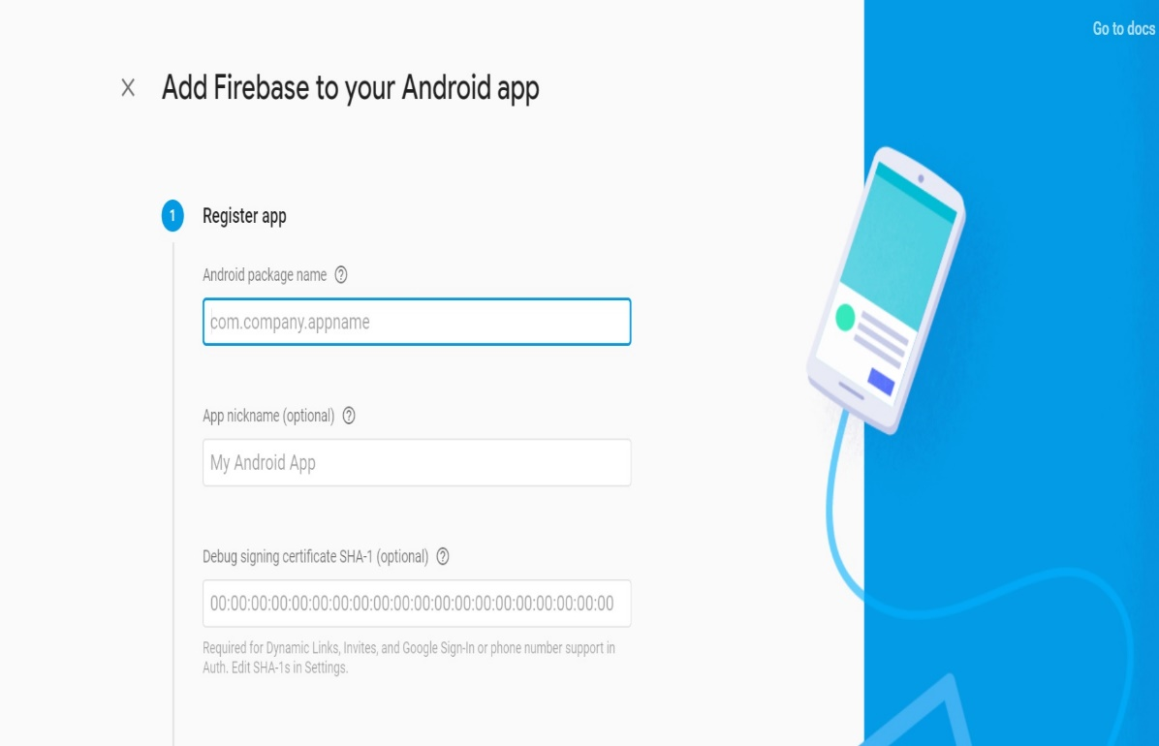

After registering the application in firebase either in an android platform or ios platform, the user data is needed to be added. Any of the available sign-in method can be enabled from the options provided by the firebase such as email, phone number, google, Facebook, Github and other identity providers as follows.

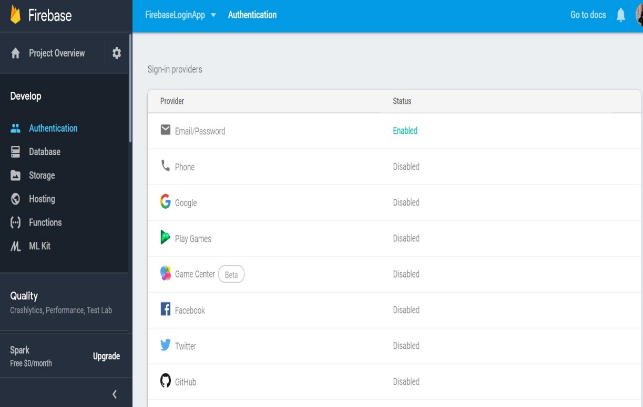

After enabling from the list of available sign-in methods, user data analytics is added. For example, to add the email account, the user mail and password was provided as follows.

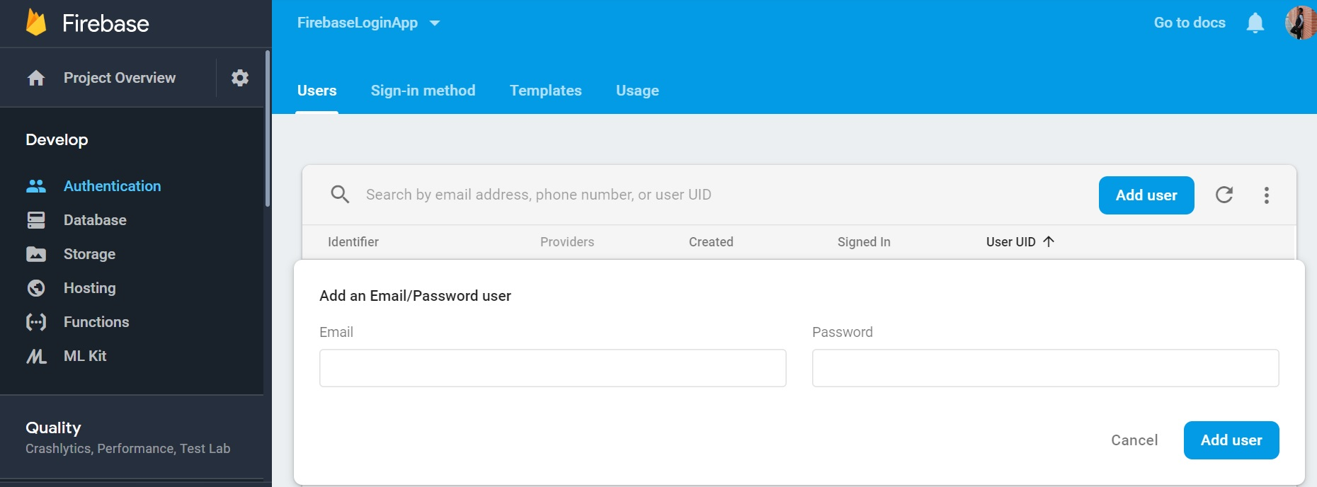

Once adding the user data analytics, the dashboard provides the list of users who has logged in to the application.

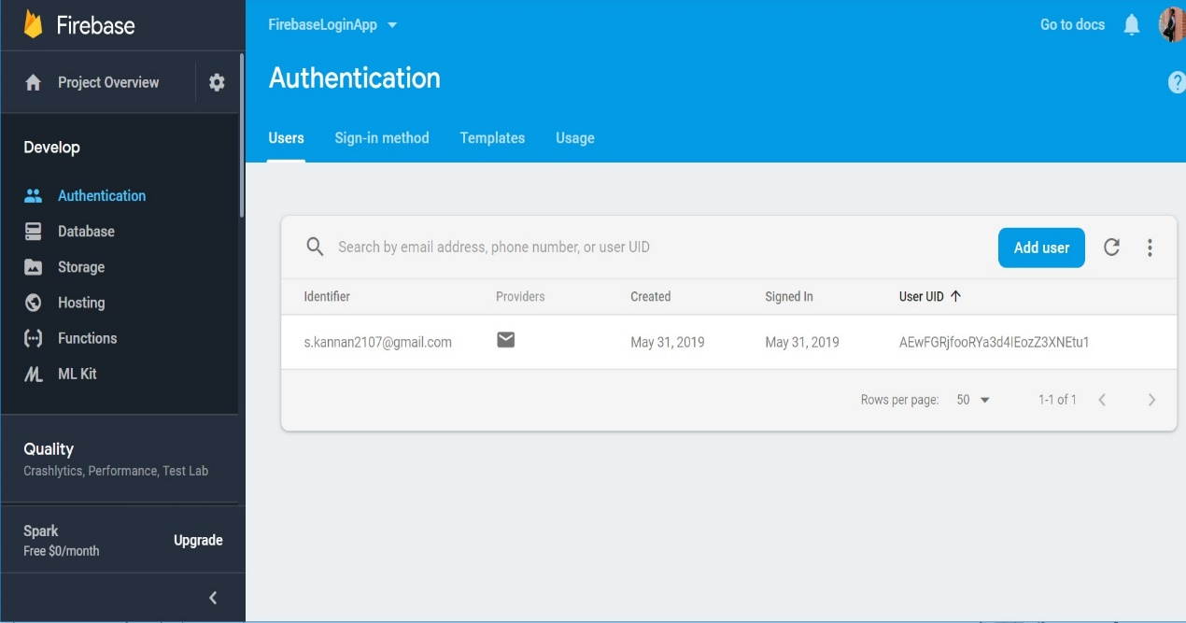

Using the firebase UI, the application is modified based on our purpose. Here we have used the application to display the application name and logo, and available sign-in methods. We have modified the user application to be signed in only through the main authentication like email, Facebook, Google.

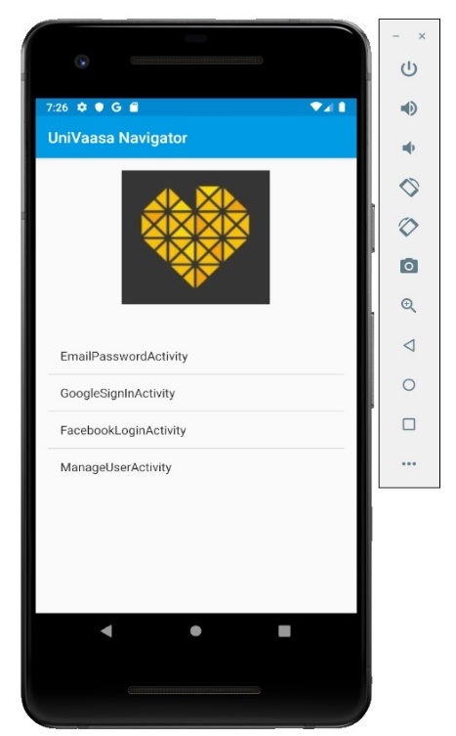

1. **Indoor Positioning System**

Indoor Positioning system provides a navigation and routing solution for indoors. For example, a shopping mall with many floors, for a satellite signals it’s very hard to penetrate through those concrete structures and reach the device. Solution for this is implementing navigation with other technologies. Here we are using Wi-Fi technology. The primary principle is calculating the positioning depending on RSSI from Wi-Fi. Android app is developed on HERE maps SDK with android studio.

HERE Indoor Radio Mapper:

This a tool used for collecting radio data (Wi-Fi/Bluetooth). Firstly floor plan is uploaded and start collecting the data. Once data collection is done click publish data.

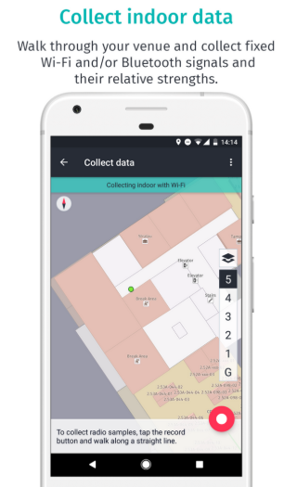

Radio map admin tool:

This tool is view the collected radio data and generated radio maps.

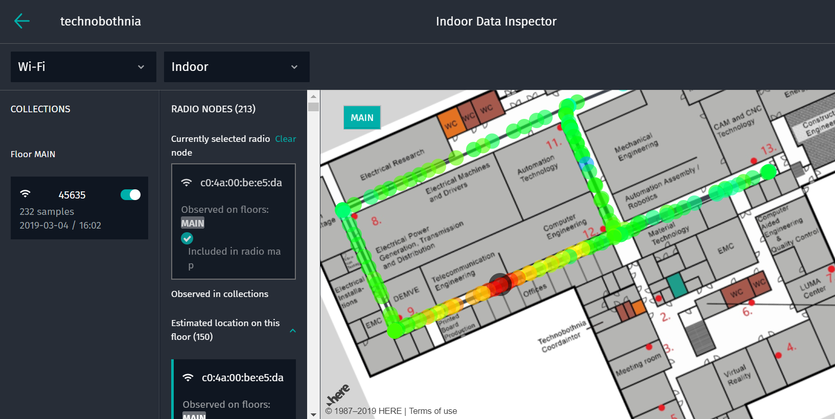

Android app:

Indoor positioning in the public venues is displayed. Here we choose public venues as rewel center. After running the application give the as DM_7828.

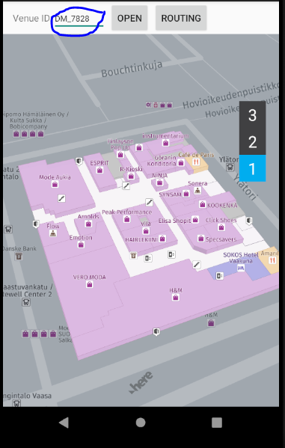

Routing implementation

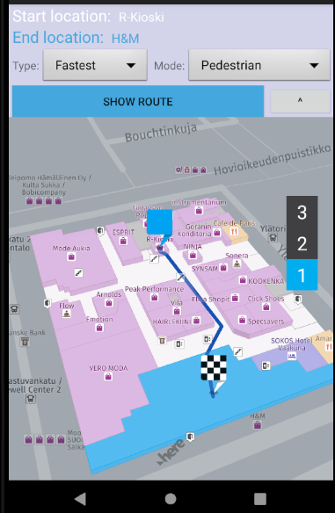

1. **Conclusion**

Through this project, we implemented the firebase authentication of user for the indoor navigation application and prototype of routing is shown through here maps. Thus, through indoor navigation precise and faster approach to the destination is possible indoors without much effort through an application in hand.